Camper Handbook 2018


BETHELWOODS

Service to Christ and sharing our faith,
by living with creation

Welcome!

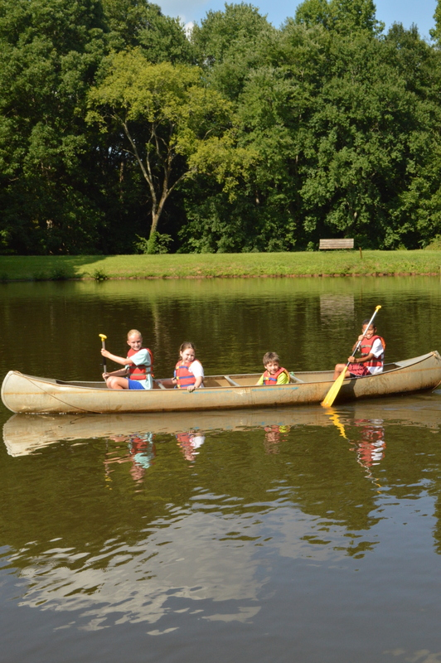

We are excited your child is coming to camp this summer! We have a wonderful program planned that will make this an unforgettable camp experience for your child. This handbook is designed to orient you to Bethelwoods Camp, to answer any questions you have, and share with you the expectation of life at Bethelwoods during summer camp.

We strive to make an environment that is safe for all who come here, that nurtures spiritual growth, and that is, of course, fun! As you’ll learn in this handbook, we do this through the selection and training of our staff.

Many people from around the world come together to make camp happen each summer. Our summer staff is a big family and each member brings with them a love for outdoor ministry. Many of the staff are behind the scenes working and praying to make each summer camp experience unforgettable!

If you have any questions about camp after reading the handbook, please contact me directly. I am happy answer any questions about camp and share with you more about the camping experience at Bethelwoods.

Let me also be the first to invite you to our Summer Camp Orientation on Saturday, May 26, from 12 – 2pm. Snacks are on us and we’d love to show you all the things we have planned and let you meet our summer leadership staff

I am looking forward to meeting you and your camper this summer!
Blessings,
Cameron Pruette
Program Director
cameron@bethelwoods.org
803-366-3722

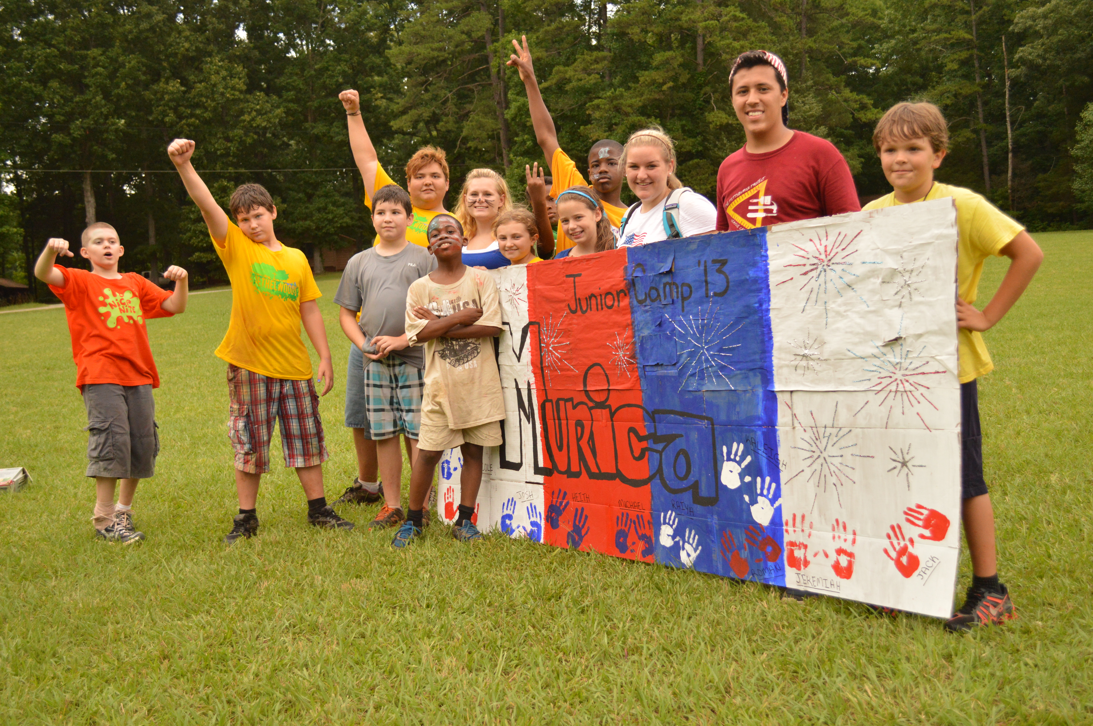

Welcome to Bethelwoods Summer Camp 2018!

Table of Contents

Meet the Staff 4

Packing List 5

Arrival and Departure 6

General Information & FAQ 7

Camper Expectations 9

Day Camp and Specialty Programs 9

Summer Theme 10

Contact Information 10

Meet the Staff

Year-round Staff

Summer Staff

CAMP DIRECTOR
Stephen McDonald stephen@bethelwoods.org

PROGRAM COORDINATOR
Cameron Pruette cameron@bethelwoods.org

OFFICE MANAGER
Colleen Johnson colleen@bethelwoods.org

FOOD SERVICE MANAGER
Liz Hille
liz@bethelwoods.org

HOUSEKEEPING
Wendy Hetherington

CAMP GRANDMA
Ann Barnwell

Each summer Bethelwoods hires a staff of 30-35 program and support staff. These people are dedicated and committed to the ministry at Bethelwoods.

All counselors are at least 18 years old and have completed 2 weeks of intensive staff training. Our staff are chosen for their enthusiasm and screened utilizing background checks and references.

Our summer staff come from all over the world. We have local staff from the Carolinas and many from all over the United States. Every year Bethelwoods hires a handful of international staff.

Each week a Volunteer Worship leader joins Bethelwoods to share in worship, Bible study, and camp fun with campers and staff. Worship Leaders are usually pastors or church educators from Providence or Charleston Atlantic Presbyteries.

Bethelwoods believes that a quality staff is the “key ingredient” to a successful and safe camping experience. All of the staff are enthusiastic and dedicated Christians. They have been screened, selected, and trained to ensure an exciting and meaningful camp experience. The counselors have all graduated from High School and are all certified in First Aid and CPR. The staff receives eleven days of intense training at the beginning of the summer and this continues with on-going instruction throughout the season. This training equips the staff with skills that enable them to create a physically and emotionally safe environment for all campers.

Packing List

Clothing

Adventure Programs

- Long pants/jeans
- Shorts
- Swim suit
- Closed Toed Shoes
- Sandals with back strap
- Socks and undergarments
- Shirts
- Sleepwear
- Jacket, sweater and/or sweatshirt
- Plastic rain coat or poncho
- Hat

- Hiking Shoes
- Sandals with back strap
- Sleeping bag
- Water bottle (2)
- Backpack (optional)
- Ground pad (optional)

- Bath towel & washcloth
- Beach towel
- Soap & Shampoo
- Toothbrush and toothpaste
- Comb/Hair brush
- Insect repellent
- Sunscreen
- Dirty clothes bag

Personal Items

- Pillow and pillow case
- Sheets & blanket OR
- A sleeping bag

Bedding
- Medication
- Bible
- Water bottle
- Writing paper and pen or pencil
- Stamps
- Reading book
- Flashlight (and extra batteries)
- Small daypack for carrying items
- Camera

Other

Day Camp

- Swim Suit
- Towel
- Water Bottle
- Sunscreen
- Insect Repellent
- Tennis Shoes
- Change of Clothes
- Small Backpack
- Book (optional-for rest time)
- Pillow (optional-for rest time)
- Small Backpack

Do Not Bring
- Portable Electronic Devices (iPad, iPod, Kindle, Nook, DVD, MP3)
- Personal Gaming Systems
- Laptops
- Cell Phones
- Snacks/Gum/Drinks
- Alcohol
- Drugs
- Weapons
- Knives
- Fireworks
- Pets
- Jewelry & Other Valuables
- Cash

Arrival and Departure

Arrival &Check-in

Closing Worship & Departure
Check-in is from 3:00-5:00pm on Sunday
Please bring with you to check-in: all forms if not previously returned or completed online (health history, high ropes, etc.), medication, and remaining balances

Step 1: Welcome and Forms Table
Pick-up any forms you need to complete before your check-in
Step 2: Check-in and Balance Due
Check in with Bethelwoods staff to find out where you are staying and who your counselor is. Forms and Balances due will be turned in at this time as well as camp store money.
Step 3: Health Center
Turn in your health history form and all medication here. The form must be fully completed. Please bring medication in the original container with name and directions. Medications should be turned in to the Health Center staff in a zip lock bag labeled with the camper’s name.

Closing Worship begins at 5:00 pm on Friday Afternoon

MEDICATION: Please sign out any medication from the health center
SIGN OUT: Parents will need to sign out campers with their counselor. Please make sure you update who is allowed to pick up you child, only authorized persons will be able to sign out campers. A picture ID is required.
LUGGAGE: Campers luggage will be packed and ready for loading at their cabins. Please do not pick up luggage before the closing program.
CAMPER TOURS: After Closing Worship you are welcome to have your camper give you a tour of camp. The camp store will also be open at this time.

General Information & FAQ
MAIL/EMAIL: Camper mail can be sent to: (camper's name), Bethelwoods, 922 West Mount Gallant Road, York, SC 29745-7475. You can also email a letter to campermail@bethelwoods.org or fax to (803) 366-3565. Please limit all email and faxes to one page. We cannot process attached files. If you would like to receive a note from your camper by email or fax, message sheets can be purchased at the camp store (three sheets for $1.00). During the camp week, these sheets will allow your camper to send a one-page message to an email address or fax number.

CAMP STORE: A 2018 summer camp t-shirt is included in the cost of registration. Campers are also invited to bring money for the camp store. Money will be banked during check-in and campers will have the opportunity to spend the money at designated times during the week on snack, drinks, and camp merchandise during daily visits to the camp store. There is a limit of $20.00 on each camper’s camp store account. All money left in the camper’s account will be returned to the parents on Friday after the closing program.
HEALTH CARE: Please remember to return your completed Health History form online or send a complete and signed copy to camp. The form has important information that we need in order to prepare for your time at camp. Campers will meet with the Health Care Manager during check-in on the first day of camp. Please bring all medications in their original container with the camper's name, name of medication, dosage information and instructions for its use. All medications will be collected and kept by the Health Care Manager during your time at camp.

In the event of sickness or injury the camper’s parents will be contacted. For sickness lasting more than 12-24 hours parents will be advised to pick up their camper. For accidents, injuries, or sickness that require treatment or outside medical assistance the parents will be notified by a Bethelwoods Director or Health Care Manager.

HOMESICKNESS: Homesickness is a natural feeling that many campers experience while away from home. Usually the feeling passes in a couple of day and the camper enjoys their time at camp. If a camper becomes homesick, the staff and other campers will be supportive of them overcoming these feelings.

Parents and friends are invited to write cheerful letter to support and encourage campers while at camp. Since talking to their parents directly on the phone increases a camper’s homesickness the camp policy generally does not include a phone call between a parent and camper. If you receive a homesick letter, please realize the feelings your camper had when they wrote the letter may have passed. If homesickness continues for an extended time, parents will receive a phone call from Bethelwoods Staff.

General Information & FAQ

FOOD: Please do not send food with your camper to camp. Meals at camp are nutritionally balanced and prepared by our loving and experienced kitchen staff. Desserts are served at dinner each night and snacks offered through out the afternoon and evening as well as the camp store being open.

Dietary restriction should be noted on the health history form and discussed with Bethelwoods staff at registration. For food allergies, campers may bring alternative items to be left in the camp kitchen.

LAUNDRY: Laundry facilities are not available for camper use. Emergencies, such as bedwetting, will be handled by camp staff in a discreet manner. LIT and CIT campers will have a chance to use camp laundry facilities on the weekends.

LOST AND FOUND: Please label your campers clothing and personal items. Lost and found items will be displayed at closing worship on Friday afternoon. All lost and found will be kept for 2 weeks after the end of a camp session before being donated to a local charity.

VISITORS: Visitors, even family and friends, are strongly discouraged. Due to the short time a camper is at camp, most visits have a negative effect and can sometime bring on homesickness. Bethelwoods staff is happy to give you a camp tour before the start of the camp session. This is for the security of all campers. If you need to stop by camp for any reason, all visitors must check in at the office.

CAMP EXPERIENCE: While at Bethelwoods, your child will be part of a “family group” comprised of a group of boys (with their male counselor) and a group of girls (with their female counselor). It is with this family unit that the camper will do most of the camp activities. In the evenings, these small groups come together for worship, snacks, and an evening activity (such as a campfire, all-camp swim, or field games). Camp days are filled with a variety of activities including Bible Study, archery for older campers, swimming in the pool, canoeing on the lake, arts and crafts, and a variety of games.

Day Camp & Specialty Programs

Camper Expectations
DAY CAMP: Day Camp drop off is daily between 7:15am-8:15am. Breakfast, Lunch, and Snacks will be provided. Please send your camper with a swim suit and towel each day, we will swim everyday if the weather allows. Pick up is between 5:00-5:30pm. Bethelwoods reserves the right to charge a $50 late fee for campers picked up after 5:30pm.

MADD CAMP: Campers are invited to bring musical instruments to these camps, we will do our best to incorporate them into services and productions.

ADVENTURE PROGRAMS: Woodwise, Riverwalkers, and Rock, Hike, and Raft all require campers to bring a good sturdy pair of tennis shoes or hiking shoes and shoes that can get wet (sandals, water shoes, old tennis shoes etc.). Bethelwoods will provide all the needed equipment and trained staff for each trip.

LIT/CIT: LIT and CIT campers continue programing on the weekends between regular week long camp sessions. There will be time for rest, relaxation, fellowship, fun, and laundry on the weekends. LIT and CIT campers will attend a local church on Sunday morning, please pack church clothes. Make sure to fill out the LIT/CIT Travel Form!

Camp is an inclusive place where campers can be themselves.

To promote and protect an atmosphere of inclusivity for all campers Bethelwoods has expectations that all campers and staff must meet. All members of the camp community are expected to treat on another as a Child of God with respect, care, and honesty, in a socially acceptable manner. Disrespectful behavior, constant disobedience, or refusal to carry out instructions will result in disciplinary actions.

Discipline will be approached through the notion of teaching about choices. Our approach to discipline is grounded in grace. A Bethelwoods Staff member may use the following ways to help a camper grow in self-discipline: a glance from a counselor, a quiet word, time away from an activity or removal of privileges.

If these measures are not effective a Director will be informed which can lead to phone calls made home, and possibly being sent home without a refund.

We care about your camper and their safety so we have this disciplinary procedure in place to protect them and ensure everyone has a great camp experience. We are looking forward to a fun, safe, and memorable summer!

BEYOND BELIEF

THIS SUMMERS THEME BEYOND BELIEF: THE UNIVERSE OF GOD, INVITES CAMPERS TO EXPLORE THEIR FAITH BY ASKING THE “BIG” QUESTIONS, TO GO…BEYOND BELIEF!


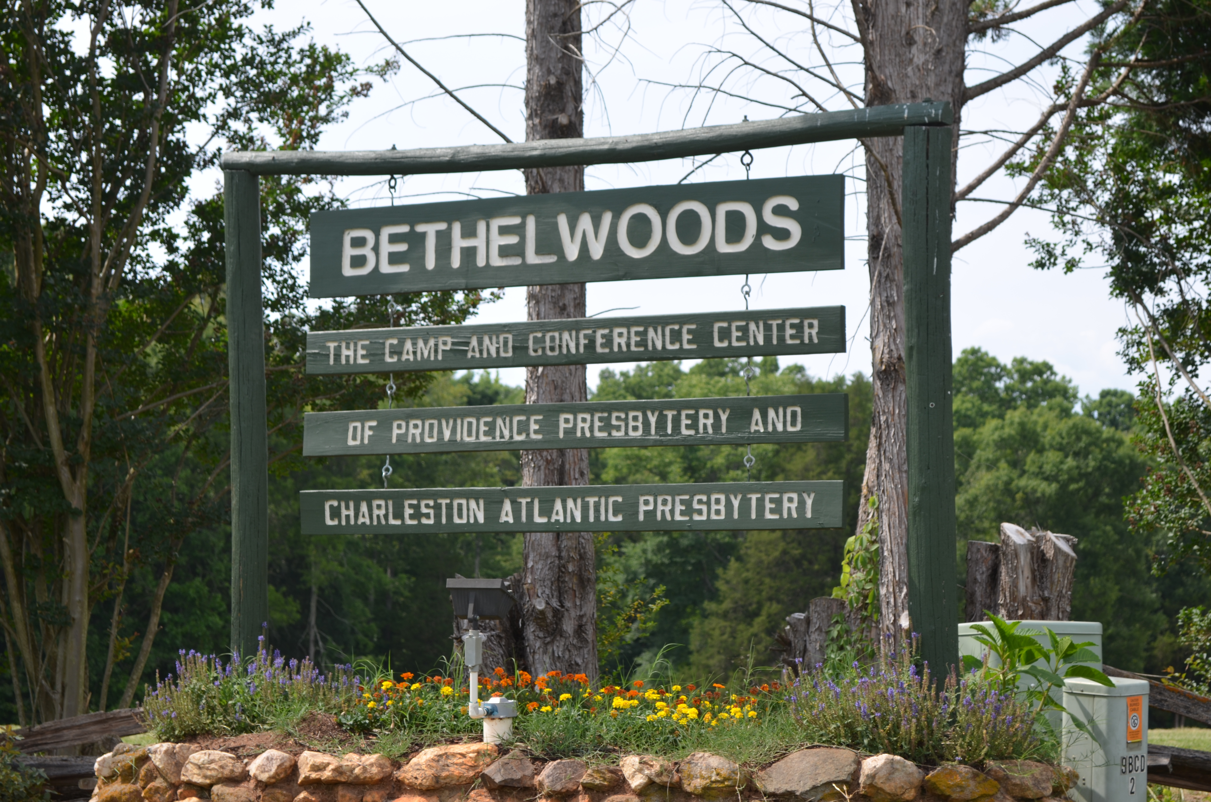

Bethelwoods Camp and Conference Center
922 West Mount Gallant Road
York, SC 29745

Office Phone: 803.366.3722
WEBSITE www.bethelwoods.org
EMAIL info@bethelwoods.org

Summer Theme

Contact Information

